YouTube is a game . . .
…or, to be more specific, it is an MMO-RPG. You need to level up, gain skills, explore the Internet, and choose a class. Don’t believe me? Maybe this will clear things up…
This is my YouTube Channel Stat Page in video game terms.
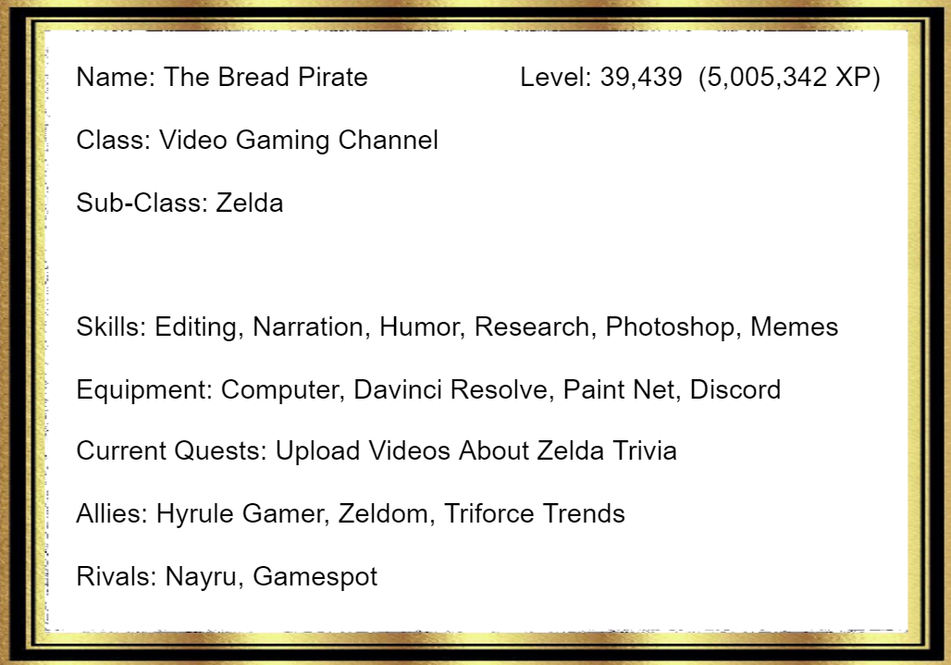
Don’t count on luck.
To get big on YouTube you need Skill, Strategy, and Endurance.
You have as many subscribers as you deserve. If you’re not happy with it, then get better. Hone your skills. Study other Youtubers.
Some chumps have one or two videos that get a million views.. but then none of their other videos get views. These are the kind of people who got “lucky” and didn’t have a long-term strategy. Do you remember the person that uploaded that cute video of a Sneezing Panda? OF COURSE NOT! No one remembers them. They had no skills, strategy, or ability to replicate the same success. They got what they deserved…
But you are better than that!
Sometimes, YouTube won’t promote your content; trust me, I know. It took me 9 years to get 100 subscribers. Hence, you need endurance. It is the thing that keeps you going when things are bleak. You need to keep making videos until you find something that sticks. It might take months, or even years, but it will eventually happen.
It takes hard work to get big on Youtube. The sooner you realize that, then the sooner you can stop your self loathing and start making good videos!
Don’t be a sneezing panda!
If You Want Views, Get People Curious
People click on videos for one of two reasons…
- They Need Something (Tutorials and Walkthroughs)
- They Want Something (Entertainment)
These two types of videos require two approaches.
When making a thumbnail for a “Want” Video you must focus on getting people curious.
- Ask a compelling question.
- Make a bold claim (the more outrageous it sounds the better, just don’t lie or exaggerate)
- Show something strange (Ex. a video game glitch, or a strangely photoshopped image)
On the other hand if you are making “Need” videos, I got no advice. I haven’t made many of those. You should study how other “Need” Youtubers are making videos.
Be Attention Grabbing
Be attention grabbing, but don’t use clickbait.
Clickbait is when you lie or greatly exaggerate about the stuff in your video. Don’t do that. Be attention-grabbing but also be honest with your thumbnails. You will find success when you do both.
Ask for criticism.
Find a friend or family member who watches a lot of social media, then ask them for BRUTALLY HONEST criticism. You can also reach out to a content creator for help.
Always.
Ask.
For.
Criticism.
It is one of the best ways to improve your content.
If your friend tells you “Your videos are too fast” then try slowing them down. If your dad says, “I don’t understand what your thumbnail is about” then try making it clearer.
Study Successful Youtubers
Pay attention to the things your favorite Youtubers do. Then, replicate those things. It’s NOT stealing if you put your own twist on it.
Look at these two thumbnails…
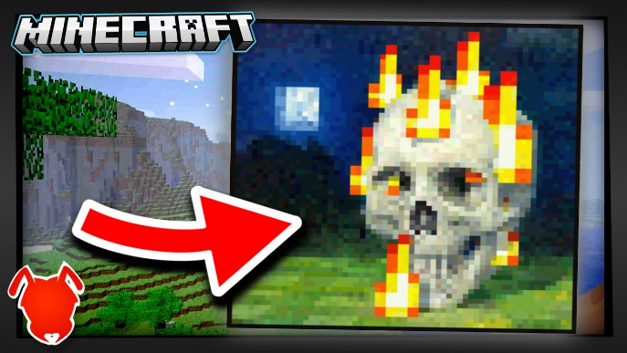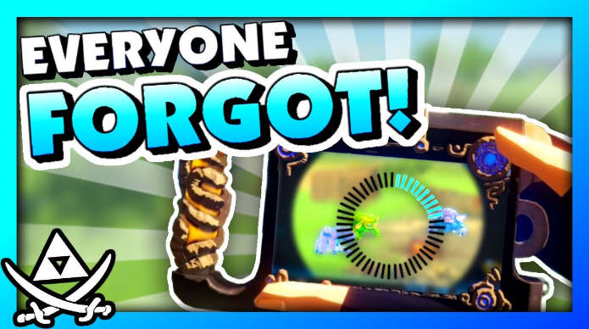
The left one is from AntVenom, and the right is from me. I liked his thumbnail style so I used it as inspiration. “It’s not stealing if you put your own twist on it.”
Be concise.
Don’t waste the viewer’s time. You can make slow videos, but don’t ramble. Be efficient with time. Don’t worry about making the video a certain length. In fact, there is a trend on the internet towards shorter videos! People like it when you are efficient with their time.
Make Thumbnails Understandable, Even When They are Small
When you’re photoshopping, zoom out from time to time. That way you can see how your thumbnail looks on the Home Page. Your image should be understandable, even when it is tiny.
Give Credit
- When you use music in a video, credit the artist in the description of the video.
- When you use another YouTuber’s research, give them credit.
- When you’re scrolling through reddit and see a post that inspires you to make a video, give that redditor credit.
Just give people credit.
Watch Out For Collaborative Channels
AKA, channels that are run by multiple people at once. They rarely work, especially when the collaborators already have personal channels. I’ve been a part of three separate collaborative channels. Only one of them is still active and that’s because I took it over and turned it into The Bread Pirate. (Go to August 12th, 2017 on the Timeline to hear that story.)
Don’t Promise to Respond to Every Comment
Instead, say you will respond to as many as possible, or that you will reply to the first 50. I say this from experience. 😅

Don’t Expect Revenue
If you want to do Youtube for the money… don’t.
Youtube is unpredictable, it will take years to gain the skills you need, and the equipment is expensive. If you want to be a Youtuber, do it because you think it’s fun; that should be your starting point. Then… if you are good at it you might make money.
If you become a Youtuber because you expect to make a quick buck, you’re out of luck.
Wait Before You Buy Expensive Equipment!
Check if you enjoy making videos before you buy expensive computers, editing software, and cameras. Start with a phone or cheap editing software and see if you have fun making videos. After that, you can get shiny expensive stuff.
Many Youtubers will tell you, “You don’t need professional equipment to be a Youtuber,” and they are only slightly lying to you. You can be a Youtuber no matter what equipment you have, but to become a BIG Youtuber you will eventually need better tools. Just don’t worry about that until you are sure you have fun making videos.

Slow The Heck Down!
Don’t talk too fast, or create edits that are too fast for the viewer to comprehend. It can be funny to make a gag appear on screen for a second and disappear before the viewer has a chance to process it, but this should be done sparingly.

I honestly have no clue how some of my videos from the summer of 2021 got so many views. I was talking at the speed of an auctioneer. It makes it difficult to process what’s happening.

Please, add breaks into your speech. The breaks can be as short as half a second. Don’t be like me in my older videos.
Think Like a Viewer!
Some people consider this the MOST helpful tip of all. And I can’t blame them.

When you make a video, think… “Would a viewer on YouTube be interested in this?” or better yet… “If I were scrolling through YouTube and saw my video would I click it?”

Chances are… no.
But that’s okay! I was able to fix my channel and so can you. Just be critical of yourself.

When a video gets fewer views ask yourself, why would a viewer not want to click on this video? And when a video has lower watch time ask yourself, what made viewers leave this video?

The problem is NEVER the viewer. It is always your channel.

Have Fun!
If you don’t have fun with YouTube, then you will get burnt out quickly. Your content will also decline in quality.
That being said… You will still need to do some hard work. But if you find Youtube to be fun, then you will be able to push past the hard parts and find success.

That is the end of my list.
During your YouTube journey, you will find more tips. Some of them will be great (and some will suck). But at the end of the day, YOU are your best teacher. Be self critical, work hard, and study successful YouTubers.
One last tip: Don’t make YouTube your life. Remember, it is just a game.

